This is a specially designed power supply that generates high voltage pulsating DC output with auto reversing timing control and mainly find application in the cleaning of solar panels.
HV AUTO-REVERSEING PULSED DC POWER SUPPLY

20kV, 500W

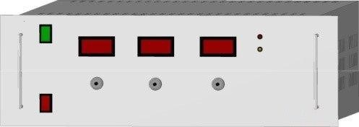
Features:
- Regulated
- High Frequency Stability
- 19” Rack Mountable

Technical Specifications
PARAMETER | SPECIFICATION
Input Voltage | 230V ±10% AC, 50Hz, single phase
Output Voltage Range | 6kV to 20kV DC peak to peak (+10kV & -10kV pulse)
Output Power | 500W
Output Waveform | Pulsating DC
Pulse Frequency | 1Hz to 100Hz
Line Regulation | <1% for ±10% variation in input voltage
Regulating Mode | Constant voltage
Voltage & Frequency &Reversing Timing Control | By 10-turn potentiometers with lockable counting dial
Protections | Against short-circuit and arc  During short circuit, power supply trips & to be reset manually
Front Panel | Power ON/OFF switch with indication  HV ON/OFF switch with indication  3½ digit meters for output positive voltage, negative voltage and frequency  10-turn potentiometers for voltage, frequency & reversing time control  LED indication for positive & negative pulses
Back Panel | Socket for mains input with 250V, 10A 3 conductor power cord of 1.5 meters  Fuse holder with fuse  Detachable Connector for HV output  Stud for grounding the unit
Topology | High frequency switch mode
Cabinet | 19” rack, powder coated
Output cable | 10ft of HV DC cable
- OEM Customization Available
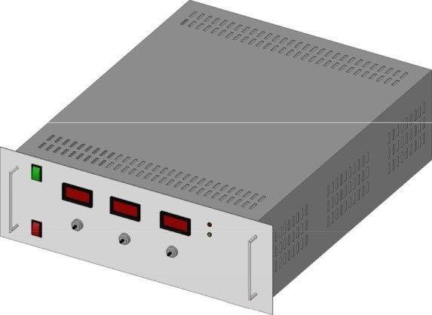
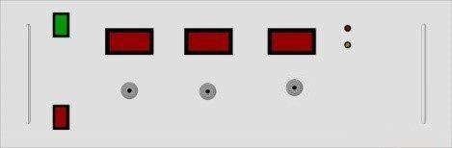

For any queries or customization requests contact us at info@ionics.co.in
For product line information visit us at www.ionics.co.in

